**Why Do We Add Bias in a Neural Network?**

In a neural network, **bias** is an additional parameter that helps the model learn patterns more effectively. It plays a crucial role in adjusting the output of neurons and improving the flexibility of the model.

**1. Bias Shifts the Activation Function**

Without bias, the activation function (like **sigmoid, ReLU, or tanh**) would always pass through the origin (0,0). This means the neuron would be limited in learning patterns that require shifting.

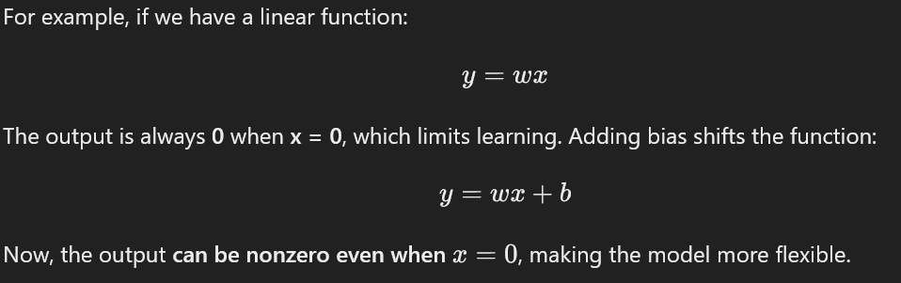

**2. Bias Helps in Learning Complex Patterns**

* Without bias, all neurons in a layer would be forced to pass through the origin, limiting their ability to model complex patterns.
* Bias allows the neural network to **better fit** the data by shifting activation functions as needed.

**3. Example in a Simple Neural Network**

* **Without bias:** The decision boundary is forced to pass through the origin, reducing flexibility.
* **With bias:** The decision boundary can shift, allowing the network to classify more accurately.

**4. Practical Impact of Bias in Neural Networks**

* It allows neural networks to approximate non-zero-centered functions.
* It improves model convergence during training.
* It helps in learning from different distributions of input data.

**Conclusion**

Adding **bias** in a neural network **increases flexibility, improves learning, and allows better representation of data**. It ensures that the model can learn patterns that are not strictly dependent on the input values alone.